Command：

roslaunch turtlebot3_gazebo man.launch

gz topic -l

gz topic -e /gazebo/default//link/my_contact

gz topic -e /gazebo/default/person_walking/link/my_contact/contacts

Output：人与地面的接触信息

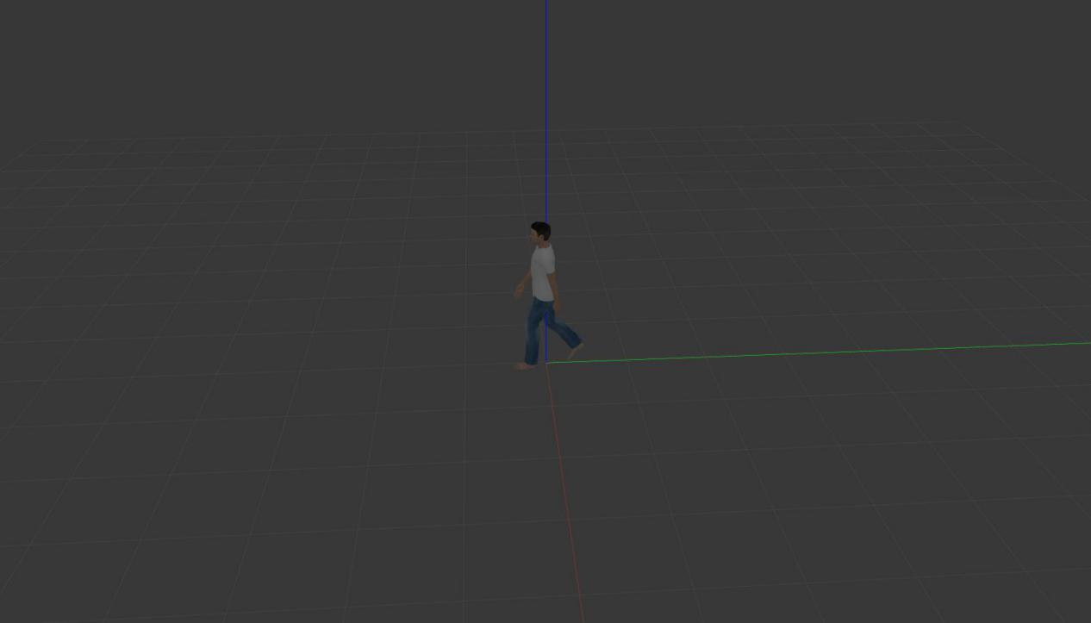

contact {

collision1: "person_walking::link::bottom"

collision2: "ground_plane::link::collision"

position {

x: -0.17495936107811194

y: -0.37501968110944195

z: -1.3511835688755081e-06

}

position {

x: 0.17504063671772102

y: -0.37498040112844366

z: -1.3500958407213607e-06

}

position {

x: -0.17504353246596946

y: 0.37498031416612743

z: -9.0524116146768834e-10

}

normal {

x: 0

y: 0

z: 1

}

normal {

x: 0

y: 0

z: 1

}

normal {

x: 0

y: 0

z: 1

}

depth: 1.3511835688755081e-06

depth: 1.3500958407213607e-06

depth: 9.0524116146768834e-10

wrench {

body_1_name: "person_walking::link::bottom"

body_1_id: 12

body_2_name: "ground_plane::link::collision"

body_2_id: 6

body_1_wrench {

force {

x: 26.572516965202663

y: 136.83805903662116

z: 479.73748486209342

}

torque {

x: -49.90540073849494

y: 58.71016873392383

z: -13.981966469457705

}

}

body_2_wrench {

force {

x: 0

y: 0

z: 0

}

torque {

x: 0

y: 0

z: 0

}

}

}

wrench {

body_1_name: "person_walking::link::bottom"

body_1_id: 12

body_2_name: "ground_plane::link::collision"

body_2_id: 6

body_1_wrench {

force {

x: -25.264417511944984

y: 134.05155543188687

z: 470.97214577132269

}

torque {

x: -49.265577003953474

y: -58.418928873633732

z: 13.984865633600831

}

}

body_2_wrench {

force {

x: 0

y: 0

z: 0

}

torque {

x: 0

y: 0

z: 0

}

}

}

wrench {

body_1_name: "person_walking::link::bottom"

body_1_id: 12

body_2_name: "ground_plane::link::collision"

body_2_id: 6

body_1_wrench {

force {

x: -2.1839303854818748e-290

y: -2.1834363172868761e-290

z: 2.1836892720397806e-290

}

torque {

x: -1.2553810244076146e-290

y: 2.4568794888147429e-290

z: 1.2010752500809063e-290

}

}

body_2_wrench {

force {

x: 0

y: 0

z: 0

}

torque {

x: 0

y: 0

z: 0

}

}

}

time {

sec: 11

nsec: 697000000

}

world: "default"

}

time {

sec: 11

nsec: 697000000

}